July 10, 2013

Dear Michigan Works! Agency (MWA) Directors:

Re: Partnership. Accountability. Training. Hope. (PATH)

For PATH participants, the One-Stop-Management-Information-System (OSMIS) will be modified effective July 15, 2013 to include the following items which are described in greater detail in this memo.

- Instrument Panel
- Countable Hours Report
- Limits History Report
- QG Report Series

Instrument Panel

A new section called “Instrument Panel” will be added to the OSMIS. A majority of the data that will be displayed on the new “Instrument Panel” is already available in other sections of the OSMIS. However, the Instrument Panel is an alternate method to view a “snapshot” of the participant’s data, which is stored in one location. The Instrument Panel will be accessible to the user via three alternate routes, as shown below.

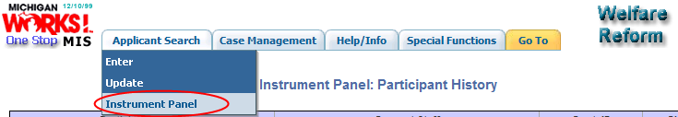

OR

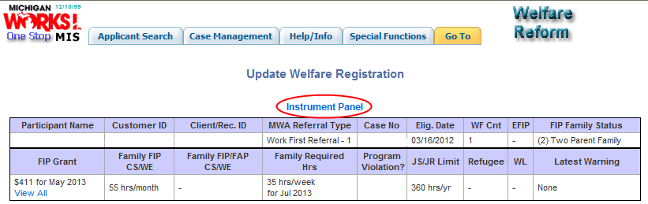

OR

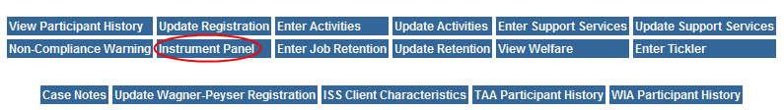

The Instrument Panel will be divided into eight tabs, with each tab consisting of data relevant to the tab label.

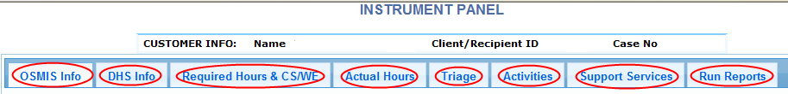

- OSMIS Info: displays information related to the participant, their referral and their current status in OSMIS.
- DHS Info: displays information pertinent to the FIP application and eligibility for both the individual participant and the case. Additionally, the case status is displayed along with any associated deferral or closure reason or ineligible date, if applicable.
- Required Hours and CS/WE: the left half of this screen provides a history of the monthly required hours for the participant. The required hours table indicates if the hours originate from the Bridges system or the DHS Data Warehouse (DW). The hours are official when DW is displayed in the ‘System Origin’ column. The right side of this screen includes monthly FIP grant amounts and the maximum allowable ‘Community Service/Work Experience’ hours. Additionally, a monthly program violation column indicates if the individual is serving a penalty for an Intentional Program Violation. If the client has both FIP Hours and FIP/FAP Hours, both hours will display; the higher value is the maximum allowable hours.
- Actual Hours: displays an itemized list of all OSMIS activities that have actual hours entered and their corresponding totals. Also displayed, the total Other Non-Countable Hours (ONCH) entered for each appropriate activity. The weeks are categorized and assigned to their respective TANF month, with the most current month on the left.
- Triage: displays information relevant to the triage appointment notification from DHS, including the date the DHS-2444 was generated, scheduled date, time, location and reason for the triage. Additionally, the header includes the latest sanction begin and end dates and current penalty count, if applicable.
- Activities: displays a list of all OSMIS activities within the participation, with begin and end dates and the number of planned hours per activity.
- Support Services: displays a list of all OSMIS support services.
- Run Reports: allows the user to run a Countable Hours or Limits History monthly report that is specific to the participant and his/her associated case.

Countable Hours Report

The Countable Hours Report will be available either via the Instrument Panel ‘Run Reports’ tab, or via the ‘Special Functions’ tab, ‘WPR Reports’, ‘Countable Hours’. The countable hours report will display details regarding the hours that count toward the client’s monthly required hours goal.

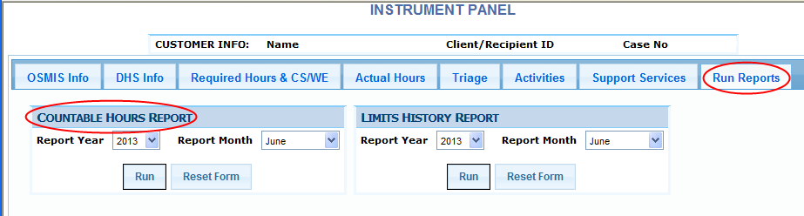

OR
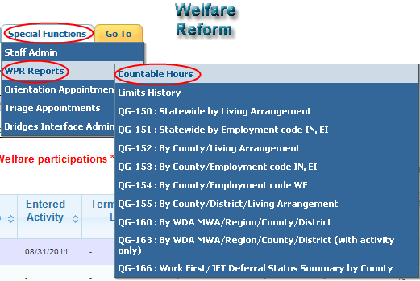

The Countable Hours Report Header will display data relevant to the Client/Recipient.

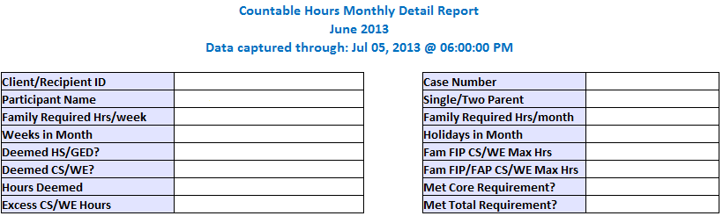

The Countable Hours Monthly Detail Report ‘Data captured through’ field will show when the data was updated to produce the report. Data entered after the date and time will not be included in the report output.

- Client/Recipient ID: The unique number that identifies the Client/Recipient.
- Participant Name: Displays the name of the client.
- Family Required Hrs/week: The number of weekly required hours will display, which is based on the FIP Family Status.
- Weeks in Month: Displays the number of weeks in the TANF report month.
- Deemed HS/GED: Yes/No is displayed, which indicates if the client is part of a case that has HS/GED hours deemed.
- Deemed CS/WE: Yes/No is displayed, which indicates if the client is part of a case that has CS/WE hours deemed.
- Hours Deemed: Displays the number of hours deemed for the client for the report month.
- Excess CS/WE Hours: Displays the number of CS/WE hours entered over FLSA limits.
- Case Number: The unique number that identifies all clients on the welfare reform case.
- Single/Two Parent: Single or Two is displayed, which indicates if the client is part of a Single or Two Parent home.
- Family Required Hrs/month: The number of monthly required hours will display, which is based on the FIP Family Status.
- Holidays in Month: Displays the number of approved holidays in the report month.
- Fam FIP CS/WE Max Hours: If applicable, displays the maximum number of hours the family can participate in Community Service/Work Experience activities for the report month.
- Fam FIP FAP CS/WE Max Hours: If applicable, displays the maximum number of hours the family can participate in Community Service/Work Experience activities for the report month.
- Met Core Requirement: Yes/No is displayed, which indicates if the case met the core required hours for the report month.
- Met Total Requirement: Yes/No is displayed, which indicates if the case met the total required hours for the report month.

The Countable Hours Report Sub-Header will display data relevant to the Reportable Hours for the case. The hours in the sub header will be averaged according to federal reporting rules.

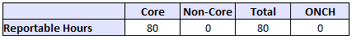

- Core: Displays the total number of reportable hours in core activities for the month
- Non-Core: Displays the total number of reportable hours in non-core activities for the month
- Total: Displays the total number of reportable hours entered for the month
- ONCH: Displays the total number of reportable Other Non-Countable Hours for the month

The Countable Hours report is summarized by “Case Summary” and “Participant # Summary”.

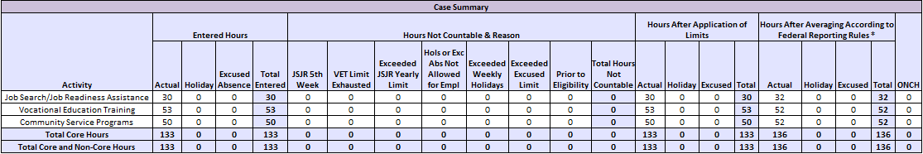

- The “Case Summary” section will display an itemized list of the activities associated with the entire case. The “Case Summary” section will provide a total list of the activities and type of hours entered (actual, holiday and/or excused absence) associated with the case. Additionally, the hours will be broken down as ‘Entered Hours’, ‘Hours Not Countable & Reason’, ‘Hours After Application of Limits’ and ‘Hours After Averaging According to Federal Reporting Rules’ segments; the last column, after the “averaging” process has occurred, represent the totals for the case.
  - Entered Hours: Displays the hours entered for actual, holiday, and excused absences
  - Hours Not Countable & Reason: Displays the hours that were not countable due to the following reasons -
    - JSJR 5th Week
    - VET Limit Exhausted
    - Exceeded JSJR Yearly Limit
    - Holidays and Excused Absences Not Allowed for Employment (This applies to DHS hours entered in Bridges only)
    - Exceeded Weekly Holidays (This applies to DHS hours entered in Bridges only)
    - Exceeded Excused Limit
    - Prior to Eligibility
  - Hours After Application of Limits: Displays the entered hours minus the non-countable hours
  - Hours After Averaging According to Federal Reporting Rules: Federal Reporting rules require that hours entered for each activity must be averaged to a weekly level by hours type (actual, holiday, and excused absence). Hours are then recalculated to reflect a monthly total.
  - ONCH: Displays the Other Non-Countable Hours entered into OSMIS
- The “Participant # Summary” section will display activities for each participant on the case. For a single parent case, the participant summary is the same as the case summary.

Furthermore, a footer will display the total amounts remaining for the following categories.

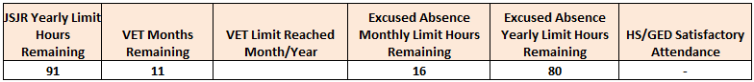
  - JSJR Yearly Limits Hours Remaining: Displays the total hours remaining in JSJR of the yearly limit, based on the client’s FIP Family Status minus countable JSJR hours
  - VET Months Remaining: Displays the total number of months remaining for the client’s hours to be countable in any VET activity
  - VET Limits Reached: Displays the Month and Year that the client met the VET 12-Month Limit, if applicable
  - Excused Absence Monthly Limit Hours Remaining: Displays the total hours remaining of “countable” Excused Absences for the month (16 per month maximum)
  - Excused Absence Yearly Limit Hours Remaining: Displays the total of hours remaining of “countable” Excused Absences for the year (80 per year maximum)
  - HS/GED Satisfactory Attendance: Displays Y/N, which indicates whether the client is attending HS/GED satisfactorily, if applicable. Displays ‘-‘ if the client is not enrolled in the corresponding HS/GED activity.

Limits History Report

The Limits History Report will be available either via the Instrument Panel ‘Run Reports’ tab, or via the ‘Special Functions’ tab, ‘WPR Reports’, ‘Limits History’.

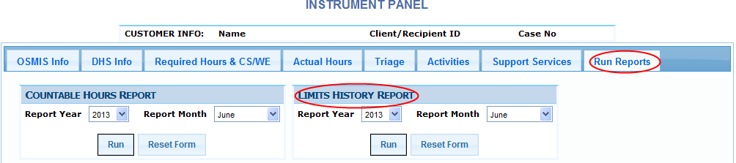

OR

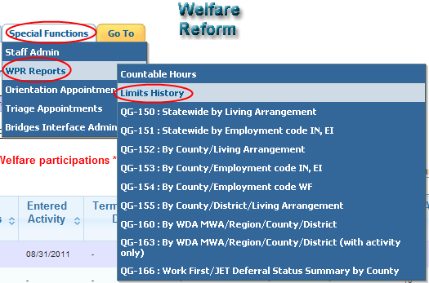

The Countable Hours Limits History report will display details regarding the lifetime, yearly and/or monthly hours limit for Job Search/Job Readiness (JSJR), Vocational Educational Training (VET), Excused Absences and Holidays.

The Countable Hours Limits History Report Header will display data relevant to the Client/Recipient. The ‘Data captured through’ field will show when the data was updated to produce the report. Data entered after the date and time will not be included in the report output.

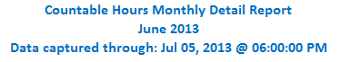

A sub header will display the total amounts remaining in several categories.

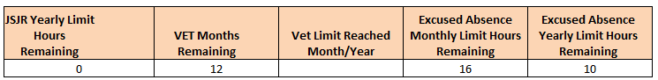

- JSJR Yearly Limits Hours Remaining: Displays the total hours remaining in JSJR of the yearly limit, based on the client’s FIP Family Status minus countable JSJR hours
- VET Months Remaining: Displays the total number of months remaining for the client’s hours to be countable in any VET activity
- VET Limits Reached: Displays the Month and Year that the client met the VET 12-Month Limit, if applicable
- Excused Absence Monthly Limit Hours Remaining: Displays the total “countable” hours remaining of Excused Absences for the month (16 per month maximum)
- Excused Absence Yearly Limit Hours Remaining: Displays the total “countable” hours remaining of Excused Absences for the year (80 per year maximum)

The row and column labels of the ‘Countable Hours Limits History Report’ will display the latest 12 calendar months. This report is broken into Job Search/Job Readiness (JS/JR), VET, Excused Absence and Holiday categories. The yearly or lifetime limits, based on family situation, are referenced and will be displayed as shown below (red circled fields). The body of the report will display the hours entered and/or countable in the given category and month.

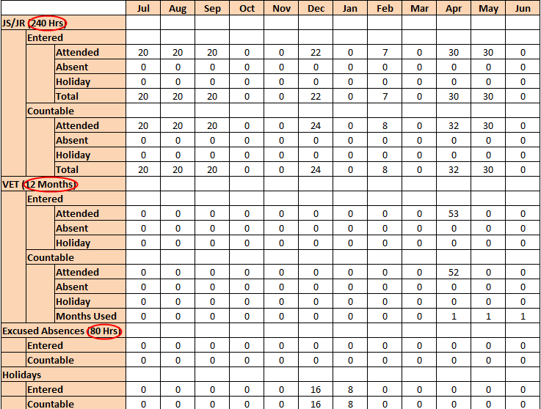

QG Reports

The QG Reports will be available on demand via the ‘Special Functions’, ‘WPR Reports’, ‘QG-XXX’. The QG reports can be ordered by report year and month and reflect data entered as of the previous day. Only the current month and the two previous months will be recalculated. Participant level listings will be limited to your MWA.

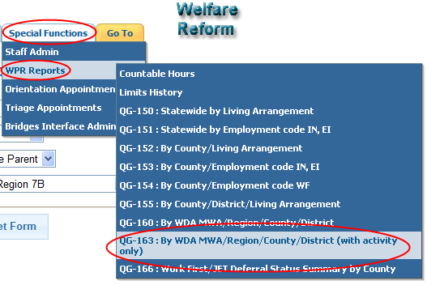

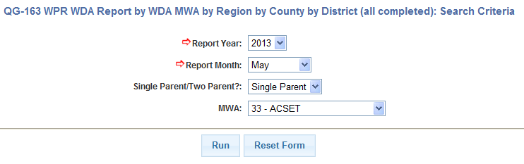

The QG 152, QG 153, QG 154, QG 155, QG 160 and QG 163, are participant level reports and will allow the user to toggle between display options, including ‘Show WPR Stats’ and ‘Hide WPR Stats’.

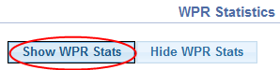

The ‘Show WPR Stats’ option will allow the user to view WPR Statistics by MWA, Region Code, DHS County and/or DHS District, if applicable.

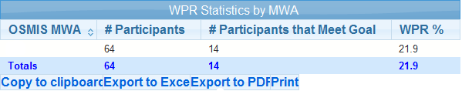

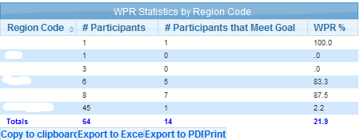

Alternately, the ‘Hide WPR Stats’ option allows the user to view just the listing of participants.

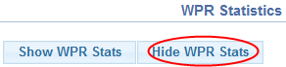

For participant listing reports, the user can filter the report results by the OSMIS Regions, DHS County, DHS District, Refugee and Meets Goal, if applicable.

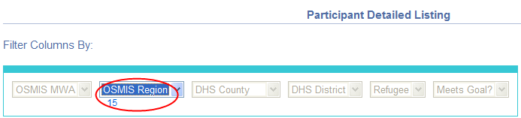

The criteria applied to the filter will display under the applicable category. To remove the filter from the report results, click the filtered value.

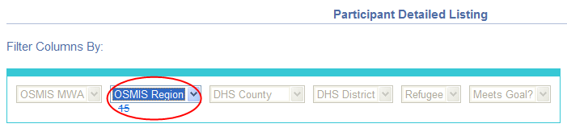

A ‘search’ box will be added to the participant detailed listing report output. The ‘search’ box will allow the user to search for any string within the report output.

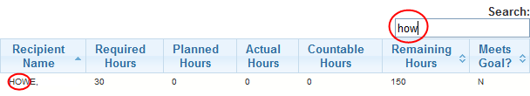

WR Header Modification

The participation hours per week header will be altered to ‘Family Required Hrs’. Currently, the ‘Part. Hrs/Wk’ field displays the required hours for one parent (35/55 hours), and ‘0’ hours for the second parent. This field will soon display the required hours (35/55 hours) on each of the parent records, and no longer display ‘0’ hours for the second parent. The ‘Family Required Hrs’ is the combined weekly requirement for both parents.

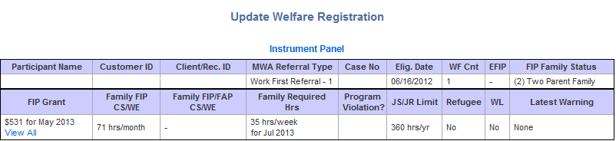

The above specified OSMIS modifications will be effective July 15, 2013. Please feel free to contact me at (517) 241-8614 or billigj@michigan.gov with any questions.

Sincerely,

Joe Billig, MIS Section Manager
Workforce Development Agency

